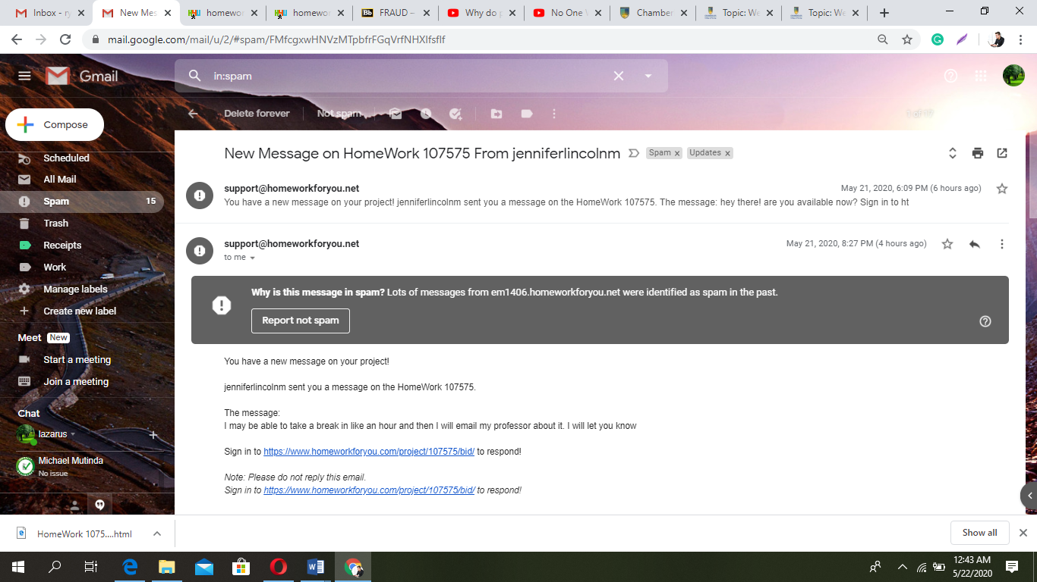

New Message on HomeWork 107575 From jenniferlincolnm
Spam | x

Updates | x
support@homeworkforyou.net |  |  | May 21, 2020, 6:09 PM (6 hours ago)
You have a new message on your project! jenniferlincolnm sent you a message on the HomeWork 107575. The message: hey there! are you available now? Sign in to ht

 | May 21, 2020, 8:27 PM (4 hours ago)
  support@homeworkforyou.net
to me

Why is this message in spam?
Lots of messages from em1406.homeworkforyou.net were identified as spam in the past.
Report not spam
You have a new message on your project!
jenniferlincolnm sent you a message on the HomeWork 107575.
The message:
I may be able to take a break in like an hour and then I will email my professor about it. I will let you know
Sign in to https://www.homeworkforyou.com/project/107575/bid/ to respond!
Note: Please do not reply this email.
Sign in to https://www.homeworkforyou.com/project/107575/bid/ to respond!
 | May 21, 2020, 9:23 PM (3 hours ago)
  support@homeworkforyou.net
to me

Why is this message in spam?
Lots of messages from em1406.homeworkforyou.net were identified as spam in the past.
Report not spam
You have a new message on your project!
jenniferlincolnm sent you a message on the HomeWork 107575.
The message:
Are you there? I am going to start the test now
Sign in to https://www.homeworkforyou.com/project/107575/bid/ to respond!
Note: Please do not reply this email.
Sign in to https://www.homeworkforyou.com/project/107575/bid/ to respond!
 | May 21, 2020, 9:24 PM (3 hours ago)
  support@homeworkforyou.net
to me

Why is this message in spam?
Lots of messages from em1406.homeworkforyou.net were identified as spam in the past.
Report not spam
You have a new message on your project!
jenniferlincolnm sent you a message on the HomeWork 107575.
The message:
Hello?
Sign in to https://www.homeworkforyou.com/project/107575/bid/ to respond!
Note: Please do not reply this email.
Sign in to https://www.homeworkforyou.com/project/107575/bid/ to respond!
 | May 21, 2020, 10:44 PM (2 hours ago)
  support@homeworkforyou.net
to me

Why is this message in spam?
Lots of messages from em1406.homeworkforyou.net were identified as spam in the past.
Report not spam
You have a new message on your project!
jenniferlincolnm sent you a message on the HomeWork 107575.
The message:
I was able to take the test at work. Thank you for responding.
Sign in to https://www.homeworkforyou.com/project/107575/bid/ to respond!
Note: Please do not reply this email.
Sign in to https://www.homeworkforyou.com/project/107575/bid/ to respond!
 | May 21, 2020, 10:46 PM (1 hour ago)
  support@homeworkforyou.net
to me

Why is this message in spam?
Lots of messages from em1406.homeworkforyou.net were identified as spam in the past.
Report not spam
You have a new message on your project!
jenniferlincolnm sent you a message on the HomeWork 107575.
The message:
I had other assignments for you but today is the last day to submit them. It is 3 assignments. Let me know if you want to do them or if I should post it to some other tutor. Thanks
Sign in to https://www.homeworkforyou.com/project/107575/bid/ to respond!
Note: Please do not reply this email.
Sign in to https://www.homeworkforyou.com/project/107575/bid/ to respond!

